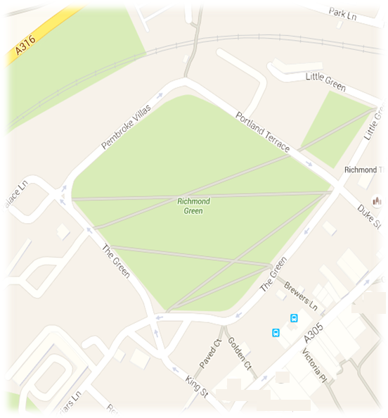
FRIENDS OF RICHMOND GREEN

cordially invite you to a talk on

THE HISTORY OF RICHMOND GREEN:
the familiar and unfamiliar

by Valerie Boyes
Historian and Trustee of the Museum of Richmond

7.00 for 7.30pm Tuesday December 1st 2015
The Theatre, Richmond Adult Education College
Parkshot, Richmond, TW9 2RE

After an overview of the history of the Green, Valerie will look at particular landmarks and a selection of personalities connected with it. She will also include some little known information gathered as a result of her research.

Entrance is FREE but please reserve seats so we can gauge numbers. RSVP to mail@FoRG.org.uk

Refreshments will be available before and after the talk

